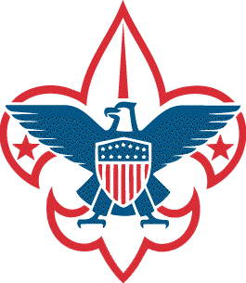
Request for Authorization to
Conduct a BSA-Sponsored
Leave No Trace Level 2 Instructor Course
Host Council: , No.
Headquarters City
In accordance with Leave No Trace Training Guidelines for Leave No Trace Level 2 Instructor Courses, authorization is requested to conduct a BSA Leave No Trace Level 2 Instructor course.
The course will be conducted at:

Dates: Weeklong; (or) Weekend One, Weekend Two.

Equipment and facilities will meet the high standards and expectations for a BSA-sponsored Leave No Trace Level 2 Instructor course.
We will use the Leave No Trace Master Educator (Level 2 Instructor) Handbook and the approved BSA supplemental materials.
A request is made for BSA National to appoint a lead instructor and one or more co-instructors.
The council has appointed the following:
Course Coordinator
Name Email Telephone
Staff Advisor
Name Email Telephone
The council recommends the following Leave No Trace Level 2 Instructor as co-instructor (optional):
Local Co-Instructor
Name Email Telephone
The host council acknowledges that they have appropriate facilities, the ability to process registrations, and a minimum of six Level 2 Instructor candidates who have agreed to take the course.
The host council has an approved preliminary budget in place. Proposed per-person fee:
The host council is following the hosting process outlined at http://outdoorethics-bsa.org/training/MEcourseHosting.php and has preliminary approval of their Outdoor Ethics & Conservation Division Manager ____________________________ (name).
The host council agrees to submit all required fees to Leave No Trace within 30 days of course completion.
Host council approval: Date
Host Council Outdoor Ethics Advocate
Date
Host Council Short Term Camp Administrator
Date
Host Council Scout Executive
A completed, signed copy of Part A of the “NCAP Local Council Authorization and Assessment Declaration" (or council equivalent) should be submitted with this form.
Scan and email the NCAP Declaration and this completed, signed Request for Authorization form to: course_apps@OutdoorEthics-BSA.org
BSA National approval: Date ___

430-114
Rev 30Jul2023

